Objective

We developed two hypotheses to build off the results presented in Kim et al., 2021, which examined the association between appendicular skeletal muscle mass and metabolic syndrome.[1](https://www.zotero.org/google-docs/?uwope3)

1. What is the association between appendicular skeletal muscle mass (ASM) per body weight and hypertension (HT) among Korean adults aged 25 to 60 years?
2. Is there a correlation between appendicular skeletal muscle mass per body weight and mean arterial blood pressure (MAP) among Korean adults aged 25 to 60 years?

Methods

**Data collection**

We used a publicly available dataset of 13,620 participants 20 years and older who underwent a voluntary routine health check up at the healthcare center of Seoul National University Boramea Medical Center from October 2014 to December 2019. Patients with insufficient data, multiple health checkups and history of malignancy were excluded from this dataset1. We further restricted our analyses to 10,759 patients aged between 25 and 60. The onset of HT for younger subjects could result from other underlying medical conditions and may have different mechanisms than those with primary HT. In hypertensive older adults, a number of studies have suggested a “J-shaped” curve, where low systolic and diastolic blood pressure is associated with elevated cardiovascular risk, thus motivating a more permissive lower bound for blood pressure when defining HT for older adults2. For a full description of the original data collection procedure, please see Kim et al., 20211. There is no missing value in our covariate set, as variables with large amount of missing in the original data were excluded from the current analysis.

**Definitions**

    Appendicular skeletal muscle mass (ASM) was calculated as the sum of the lean skeletal muscle mass of the bilateral upper and lower limbs. To better assess the relative proportion of ASM in each subject, we also included the percentage of ASM (ASM%), defined as ASM divided by body weight (kg). HT was defined as systolic blood pressure (SBP) ≥ 140 mmHg, diastolic blood pressure (DBP) ≥ 90 mmHg, or the use of blood pressure medication. Mean arterial pressure (MAP), the average arterial pressure throughout one cardiac cycle, was estimated by DBP + 1/3(SBP – DBP). History of smoking and alcohol consumption were defined as dichotomous variables for whether a subject has a smoking or drinking habit. Body mass index (BMI) was defined as the weight (kg) divided by height squared (m2). Waist circumference was recorded in centimeters (cm) and used jointly with BMI to present a more accurate depiction of body composition.

**Statistical analysis**

   Continuous variables are summarized using mean and standard deviation and categorical variables are summarized using counts and percentages. We performed bivariate and multivariable logistic regression to estimate the association between HT (yes vs no) and ASM%. The directed acyclic graph (DAG) is a conceptual framework for the underlying data-generating process and was used to inform covariate selection. A crude model and two multivariable logistic regressions were constructed. Results of the multivariable logistic regressions are summerized using odds ratios (ORs) and 95% confidence intervals (CIs).

Model 1 includes sex (female vs male) and age in years, model 2 includes history of smoking (yes vs no) and alcohol (yes vs no) in addition to sex and age. We also conducted sensitivity analyses for unmeasured confounding by calculating E-values for models that were found to have an ASM%-HT association. All analyses were performed using SAS 9.14, by SAS Institute Inc., Cary, NC, USA.

As demonstrated in Figure 1, age and sex were known to be strong unmodifiable risk factors for HT and they also highly correlated to appendicular skeletal muscle mass3,4. Thus, we included age and sex in our first model. In our next model we added history of cigarette smoking and history of alcohol use as modifiable behavioral confounders for our ASM%-HT relationship, though they have less pathophysiological support and are subject to measurement error (see limitations section).

 Although BMI and waist circumference are highly associated with HT and appendicular skeletal muscle mass, both BMI and waist circumference could be collinear with ASM as measurement of body composition5. Furthermore, as suggested by the DAG, diabetes (DM), dyslipidemia, obesity are colliders that should not be conditioned on in multivariable models (**Figure 1**).

For sensitivity analyses, we used E-values to measure the robustness of our models to unmeasured confounders. E-values estimate the minimum strength of association (on the risk ratio scale) required for an unmeasured confounder to explain away a particular treatment-outcome association6.An online E-value calculator was used to estimate E-values for the ASM%-HT association in each model if it was found to be non-null​​6–8. For E-value calculations, the outcome type was odds ratio with an outcome prevalence >15%, and the null (1.00) was used as the true causal effect to which to shift the estimate.

In addition, those who have a medical history of HT are more likely to receive anti-hypertensive medications which would artificially lower MAP and potentially bias the association between ASM% and MAP. Thus, we conducted sensitivity analyses by excluding those who had a medical history of HT and performed the same statistical analyses for ASM% and MAP as described above. The output suggests no meaningful departure from our original estimates (**Supplementary Table**).

Next, to explore the possible linear relationship between ASM% and continuous MAP, we utilized linear regression models using the same data generating procedure described above. For interpretation purposes, the ASM% exposure variable was re-scaled by a factor of 10 (ASM_10 = ASM_Wt_/10) so that the interval for ASM% exposure becomes every 10% increase in ASM%. The linearity assumption was visually assessed by plotting residuals against the ASM% predictor. A scatter plot with fitted regression line stratified by sex is presented for the relationship between ASM% and MAP (**Supplementary Figure**).

Results

A total of 10,795 participants were included in our study. Mean age (sd) was 44.1 (9.62) years. Forty-five percent of them were female. The prevalence of HT was 26.3 percent. 32.7% of the study poulation were obese based Asian and Pacific standard (**Table 1**).

The bivariate logistic regression between ASM% and HT showed no association between ASM% and HT [OR = 1.00; 95% CI = (0.99, 1.01)]. However, after adjusting for age and sex it appeared that ASM% was negatively associated with HT [OR = 0.80; 95% CI = (0.78, 0.81)). The point estimates for the ORs between ASM% and HT seems to be stable after including risk behavioral variables in model 2 [OR = 0.96; 95% CI = (0.93, 0.98)]. The ASM%-HT association in models 1 and 2 were found to be minimally-to-moderately robust to uncontrolled confounding, with an E-value of 1.46.

The bivariate linear regression between ASM% and MAP (mmHg) also showed no association between ASM% and MAP (β = 2.4; 95% CI = [1.7, 3.0]) (**Table 2a**). On the other hand, after adjusting for age and sex it appeared that ASM% was again negatively associated with MAP [β = -11.2; 95% CI = (-12.0, -10.5)] (**Table 2b**). After excluding those with known history of HT, there was no significant change, defined as more than 10%, in estimates (**Supplementary Table**).

## Limitations

We had several limitations to our analyses. The temporal relationship between ASM and HT could not be determined for this cross-sectional study and thus reverse causation may be an issue because chronic HT patients are more likely to develop more complications e.g., stroke, chronic kidney disease. These chronic complications could lead to poor nutrition and loss of muscle mass and affect ASM, although those who had a history of malignancy were excluded and age were adjusted in the final model.

We also found that sex and age appeared to be strong confounders in the ASM and HT association. However, some unmeasured confounders such as chronic kidney disease conditions may need to be addressed for further study.

Our results are also more specific to the study population that lives in the catchment area of the medical center of South Korea. The catchment area likely best represents a Korean population living in a metropolitan city. The association between ASM and HT may be different in other countries and populations with other demographic makeups.

Lastly, we were not provided with background on how certain variables were collected. Measurement error in how history of cigarette and alcohol use data was collected could lead to uncontrolled confounding.

## Conclusion

* After adjusting for sex and age, a higher ASM% was associated with decreased odds of HT.
* MAP was negatively correlated with ASM%, which is consistent with the results from logistic models. Such association persisted even for subjects without known history of HT.
* Gender seemed to be a strong confounder for the ASM% - HT relationship.

## Reference

1. Kim SH, Jeong JB, Kang J, et al. Association between sarcopenia level and metabolic syndrome. *PLoS One*. 2021;16(3):e0248856. doi:10.1371/JOURNAL.PONE.0248856

2. Anandita K, Mehta A, Yang E, Parapid B. Older Adults and Hypertension: Beyond the 2017 Guideline for Prevention, Detection, Evaluation, and Management of High Blood Pressure in Adults - American College of Cardiology. https://www.acc.org/latest-in-cardiology/articles/2020/02/26/06/24/older-adults-and-hypertension. Accessed February 22, 2022.

3. Jiang Q, Zhang Q, Wang T, You Q, Liu C, Cao S. Prevalence and risk factors of hypertension among college freshmen in China. *Sci Reports 2021 111*. 2021;11(1):1-8. doi:10.1038/s41598-021-02578-4

4. Gallagher D, Visser M, De Meersman RE, et al. Appendicular skeletal muscle mass: Effects of age, gender, and ethnicity. *J Appl Physiol*. 1997;83(1):229-239. doi:10.1152/JAPPL.1997.83.1.229/ASSET/IMAGES/LARGE/JAPP0574005.JPEG

5. Kim NH, Park Y, Kim NH, Kim SG. Weight-adjusted waist index reflects fat and muscle mass in the opposite direction in older adults. *Age Ageing*. 2021;50(3):780-786. doi:10.1093/AGEING/AFAA208

6. Van Der Weele TJ, Ding P. Sensitivity Analysis in Observational Research: Introducing the E-Value. *Ann Intern Med*. 2017;167(4):268-274. doi:10.7326/M16-2607

7. E-value calculator. https://www.evalue-calculator.com/evalue/. Accessed February 22, 2022.

8. Mathur MB, Ding P, Riddell CA, VanderWeele TJ. Web Site and R Package for Computing E-values. *Epidemiology*. 2018;29(5):E45-E47. doi:10.1097/EDE.0000000000000864

## Codebook and data dictionary

Information variables and code used for this project are stored in <https://github.com/AlycAlyc/EPIDEM207-2022-winter/tree/main/Assignment%202>

**Table 1. Characteristics of the Study Population (n = 10,759)**

|  |  |
| --- | --- |
|  | **Total  (n=10,759)** |
| **Appendicular skeletal muscle mass (ASM)** | 20.2 ± 4.90 |
| **ASM (%)** | 30.22±3.47 |
| **Age (years)** | 44.1± 9.62 |
| **BMI (kg/m^2)** | 23.69± 3.50 |
| **Waist circumference (cm)** | 83.23± 9.93 |
| **Female** | 4846 (45.0) |
| **Obesity status according to BMI** |  |
| **Under weight (BMI <18.5 kg/m^2)** | 444 (4.1) |
| **Normal (BMI 18.5-22.9 kg/m^2)** | 4469 (41.5) |
| **Overweight (BMI 23-24.9 kg/m^2)** | 2334 (21.7) |
| **Obesity (BMI >=25 kg/m^2)** | 3512 (32.6) |
| **Dyslipidemia** | 3682 (34.2) |
| **Diabetes** | 651 (6.1) |
| **History of smoking (Yes vs. no)** | 2064 (19.2) |
| **History of alcohol intake (Yes vs. no)** | 6098 (56.7) |
| **Hypertension** | 2826 (26.3) |
| Data are presented as mean ± SD or number (%) |  |

|  |  |  |  |
| --- | --- | --- | --- |
| **Table 2a. Association between appendicular skeletal mass per body weight (%) and hypertension** | | | |
|  | **OR** | **95% CI** | **E-value** |
| **Crude** | 1.00 | 0.99, 1.01 | N/A |
| **Model 1** | 0.80 | 0.78, 0.81 | 1.46 |
| **Model 2** | 0.81 | 0.79, 0.83 | 1.46 |
| Model 1 adjusted for age, sex | | |  |
| Model 2 adjusted for age, sex, history of smoking, history of alcohol intake | | | |

|  |  |  |  |
| --- | --- | --- | --- |
| **Table 2b. Expected change in MAP (mmHg) per 10% increase in appendicular skeletal mass per body weight** | | |  |
|  | **β** | **95% CI** |  |
| **Crude** | 2.4 | 1.7, 3.0 |  |
| **Model 1** | -11.2 | -12.0, -10.5 |  |
| **Model 2** | -11.3 | -12.0, -10.5 |  |
| Model 1 adjusted for age, sex | | |  |
| Model 2 adjusted for age, sex, history of smoking, history of alcohol intake | | | |

**Figure 1. Directed acyclic graph (DAG) depicting the causal assumptions driving the analytic strategy.**

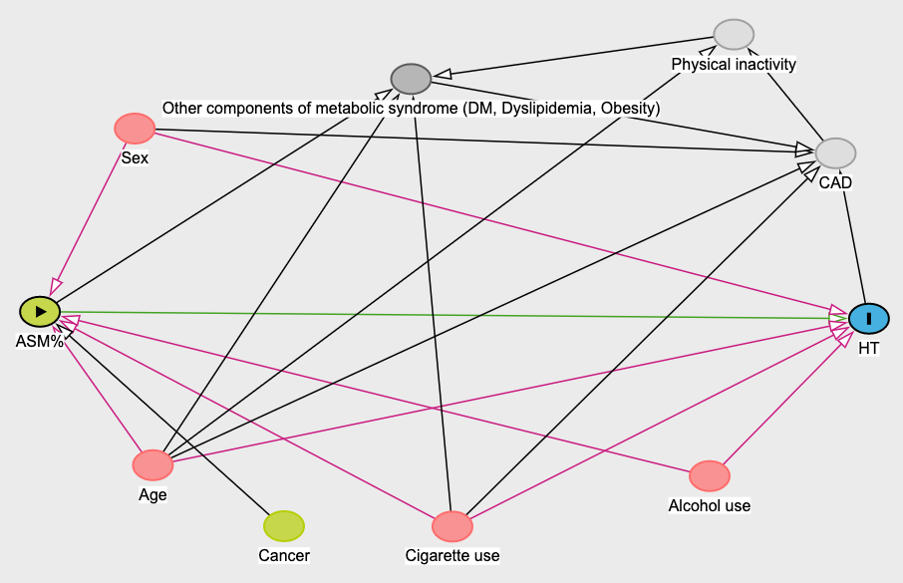

Of note, CAD and physical inactivity (nodes in grey) are unobserved variables.

CAD = coronary artery disease

DM = diabetes

|  |  |  |  |
| --- | --- | --- | --- |
| **Supplementary Table. Sensitivity analysis for expected change in MAP (mmHg) per 10% increase in appendicular skeletal mass per body weight, excluding those with known history of hypertension** | | |  |
|  | **β** | **95% CI** |  |
| **Crude** | 2.6 | 2.0, 3.3 |  |
| **Model 1** | -11.1 | -12.0, -10.3 |  |
| **Model 2** | -11.2 | -12.0, -10.4 |  |
| Model 1 adjusted for age, sex | | |  |
| Model 2 adjusted for age, sex, history of smoking, history of alcohol intake | | | |

**Supplementary Figure. Scatter plot depicting the association between ASM% and MAP, stratified by sex**

